Assignment 14

# Results from DL27C.py

## Original Image

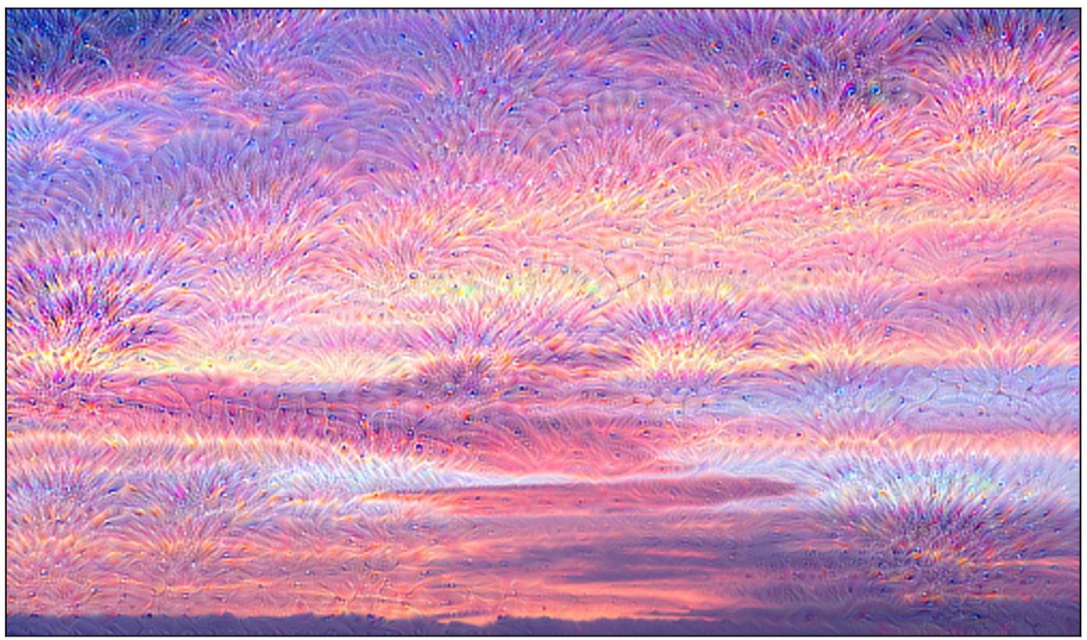

## Changing the image to https://letstalkscience.ca/sites/default/files/2021-11/underwater-scene-tropical-seabed-with-reef.jpg and using layer 20 we get

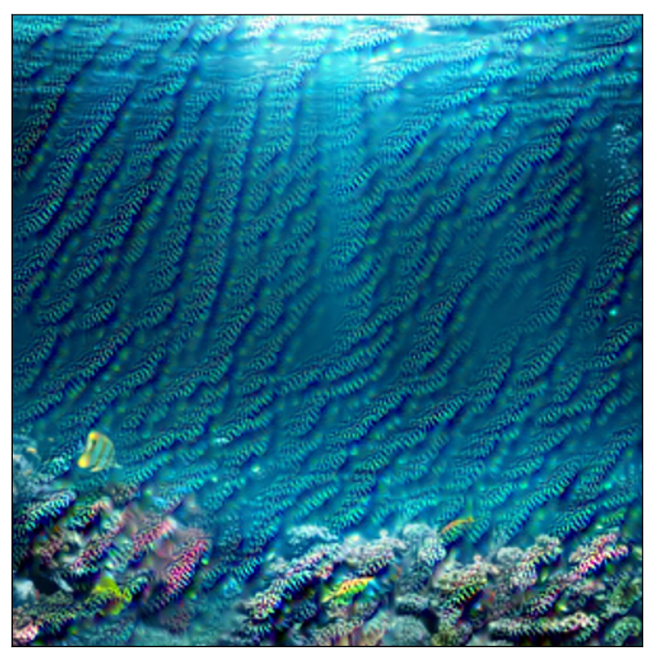

# Results from DL27D.py

## Original Image

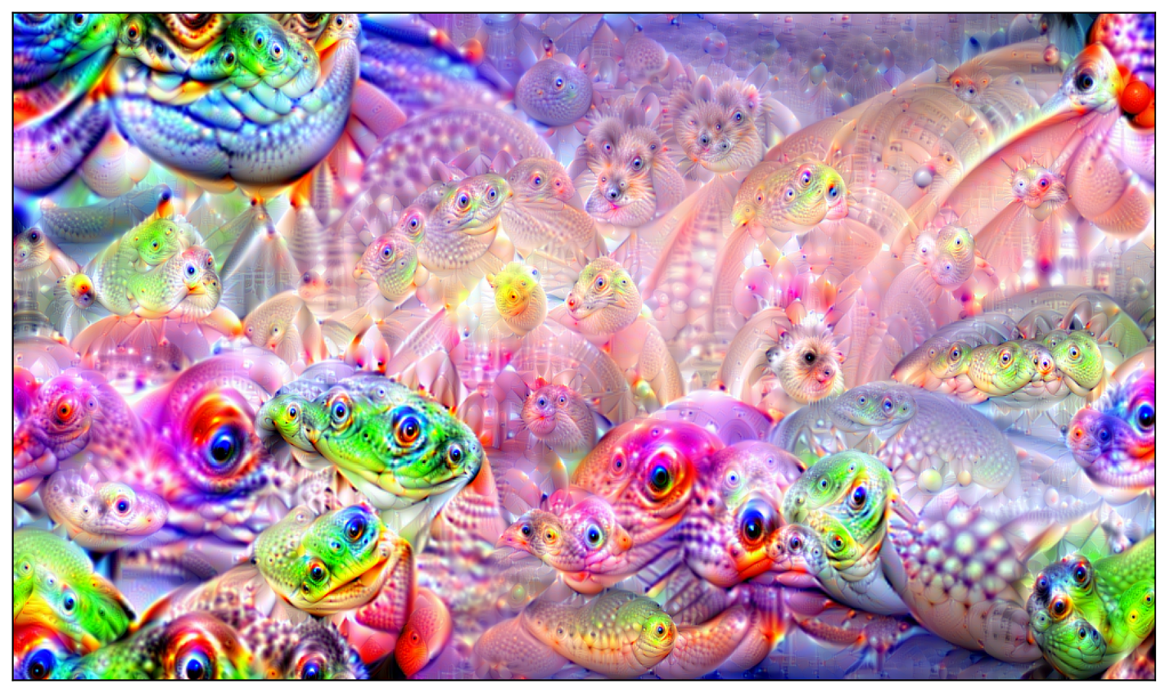

## Changing the image to <https://cdn.vox-cdn.com/thumbor/bH2RoexPP4h6T7FfWQ5hB2-v6NM=/0x125:4000x2125/fit-in/1200x600/cdn.vox-cdn.com/uploads/chorus_asset/file/23406204/GettyImages_1346022120.jpg> we get

